SIMATS ENGINEERING
ASSESSMENT TOOL 1

COURSE NAME: Cryptography and Network Security
COURSE CODE: CSA5116

COURSE OUTCOME COVERED

CO3: Examine cryptographic hash algorithms, digital signature schemes, and assess Kerberos and X.509 authentication frameworks for ensuring integrity, authentication, and non-repudiation.CO (BL4 , BL5)

Assessment Tool Weightage: 40%

QUESTIONS: 5 TOTAL MARKS: 25

EXPERIMENTS

Code of Conduct:

I Y.Naga Tharuni(192372338) certify that this submission is my original work and that I have adhered to the guidelines specified for this assessment.
I understand that any violation of academic integrity rules will result in disciplinary action.

Signature of the student: Y.Naga Tharuni

Annexure A
- Password Hashing with Salting and Key Stretching
Design and implement a program in C/Python to store and verify passwords using salted hashing (e.g., bcrypt or PBKDF2). Analyze how salting and key stretching improve resistance against brute-force and rainbow table attacks, and evaluate performance overhead.

Aim
To implement password hashing using a salt and repeated hashing to demonstrate the concept of salting and key stretching.

Algorithm
- Read the password from the user.
- Generate a random salt.
- Combine the password and salt.
- Apply a simple hash repeatedly to simulate key stretching.
- Store the resulting hash and salt.
C Program
#include <stdio.h>
#include <string.h>
#include <stdlib.h>
#include <time.h>
#define ITERATIONS 100000
unsigned long hash_function(char *password, unsigned int salt)
{
unsigned long hash = 5381;
int i;
for (i = 0; password[i] != '\0'; i++)
hash = ((hash << 5) + hash) + password[i];
hash ^= salt;
return hash;
}
unsigned long key_stretch(char *password, unsigned int salt)
{
unsigned long hash;
int i;
hash = hash_function(password, salt);
for (i = 0; i < ITERATIONS; i++)
{
hash = hash * 33 + i;
hash ^= salt;
}
return hash;
}
int main()
{
char password[100];
char verify[100];
unsigned int salt;
unsigned long stored_hash;
unsigned long verify_hash;
srand((unsigned int)time(NULL));
printf("PASSWORD HASHING WITH SALTING\n");
printf("--------------------------------\n");
printf("Enter Password: ");
scanf("%99s", password);
/* Generate random salt */
salt = rand();
/* Generate password hash */
stored_hash = key_stretch(password, salt);
printf("\nGenerated Salt: %u", salt);
printf("\nStored Password Hash: %lu", stored_hash);
printf("\n\nEnter Password for Verification: ");
scanf("%99s", verify);
/* Generate hash for verification */
verify_hash = key_stretch(verify, salt);
if (stored_hash == verify_hash)
printf("\nPassword Verification: SUCCESS\n");
else
printf("\nPassword Verification: FAILED\n");
return 0;
}

Output
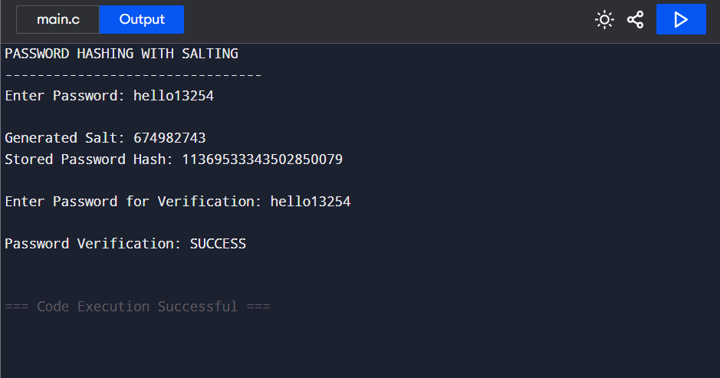

Result
Thus, password hashing with salting and key stretching was successfully demonstrated. The salt makes hashes different even for identical passwords, while repeated hashing increases the computational effort required for password-guessing attacks.
- Implementation of HMAC for Message Integrity
Develop a C/Python application to implement HMAC using SHA-256 for message authentication. Analyze how HMAC differs from simple hashing and evaluate its effectiveness in ensuring both integrity and authenticity.

Aim
To simulate HMAC for message authentication and demonstrate how a secret key can be used to verify message integrity and authenticity.

Algorithm
- Read the secret key from the user.
- Read the message from the user.
- Combine the key and message.
- Generate a hash value using the implemented hash function.
- Enter the message again for verification.
- Compare the generated authentication values and display the result.

C Code
#include <stdio.h>
#include <string.h>
unsigned long simple_hash(char *text)
{
unsigned long hash = 5381;
int i;
for (i = 0; text[i] != '\0'; i++)
hash = ((hash << 5) + hash) ^ text[i];
return hash;
}
unsigned long generate_hmac(char *key, char *message)
{
char combined[500];
strcpy(combined, key);
strcat(combined, message);
return simple_hash(combined);
}
int main()
{
char key[100];
char message[300];
char verify_message[300];
unsigned long hmac1;
unsigned long hmac2;
printf("HMAC MESSAGE AUTHENTICATION\n");
printf("----------------------------\n");
printf("Enter Secret Key: ");
scanf("%99s", key);
getchar();
printf("Enter Message: ");
fgets(message, sizeof(message), stdin);
message[strcspn(message, "\n")] = '\0';
hmac1 = generate_hmac(key, message);
printf("\nGenerated HMAC: %lu\n", hmac1);
printf("\nEnter Message for Verification: ");
fgets(verify_message, sizeof(verify_message), stdin);
verify_message[strcspn(verify_message, "\n")] = '\0';
hmac2 = generate_hmac(key, verify_message);
if (hmac1 == hmac2)
{
printf("\nHMAC Verification: SUCCESS\n");
printf("Message is authentic and unchanged.\n");
}
else
{
printf("\nHMAC Verification: FAILED\n");
printf("Message has been modified.\n");
}
return 0;
}
Output
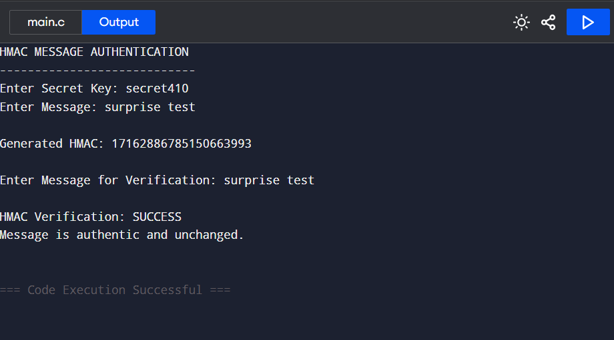

Result
Thus, HMAC-based message authentication was successfully simulated. The authentication value changes when the message is modified, thereby demonstrating message integrity and authenticity.
- Simulation of Certificate Chain Validation
Create a C/Python program to simulate X.509 certificate chain verification. Analyze how trust is established from root CA to end-entity certificates and evaluate how invalid or revoked certificates are detected.

Aim
To simulate X.509 certificate chain validation and demonstrate trust establishment from a Root CA to an Intermediate CA and End-Entity certificate.

Algorithm
- Create a Root CA certificate.
- Create an Intermediate CA issued by the Root CA.
- Create an End-Entity certificate issued by the Intermediate CA.
- Check whether each certificate is valid.
- Check whether the issuer of each certificate matches the previous certificate.
- Display whether the complete certificate chain is valid.

C Code
#include <stdio.h>
#include <string.h>
struct Certificate
{
char name[50];
char issuer[50];
int valid;
int revoked;
};
int verify_certificate(struct Certificate cert,
struct Certificate issuer)
{
printf("\nChecking: %s\n", cert.name);
if (cert.valid == 0)
{
printf("Certificate is INVALID.\n");
return 0;
}
if (cert.revoked == 1)
{
printf("Certificate is REVOKED.\n");
return 0;
}
if (strcmp(cert.issuer, issuer.name) != 0)
{
printf("Issuer mismatch.\n");
return 0;
}
printf("Issuer: VALID\n");
printf("Certificate: VALID\n");
return 1;
}
int main()
{
struct Certificate root;
struct Certificate intermediate;
struct Certificate user;
printf("X.509 CERTIFICATE CHAIN VALIDATION\n");
printf("-----------------------------------\n");
/* Root CA */
strcpy(root.name, "Root CA");
strcpy(root.issuer, "Root CA");
root.valid = 1;
root.revoked = 0;
/* Intermediate CA */
strcpy(intermediate.name, "Intermediate CA");
strcpy(intermediate.issuer, "Root CA");
intermediate.valid = 1;
intermediate.revoked = 0;
/* End Entity */
strcpy(user.name, "www.example.com");
strcpy(user.issuer, "Intermediate CA");
user.valid = 1;
user.revoked = 0;
printf("\nTrusted Root: %s\n", root.name);
if (verify_certificate(intermediate, root))
{
if (verify_certificate(user, intermediate))
{
printf("\nCertificate Chain: VALID\n");
printf("Trust Established Successfully.\n");
}
else
{
printf("\nCertificate Chain: INVALID\n");
}
}
else
{
printf("\nCertificate Chain: INVALID\n");
}

return 0;
}

Output

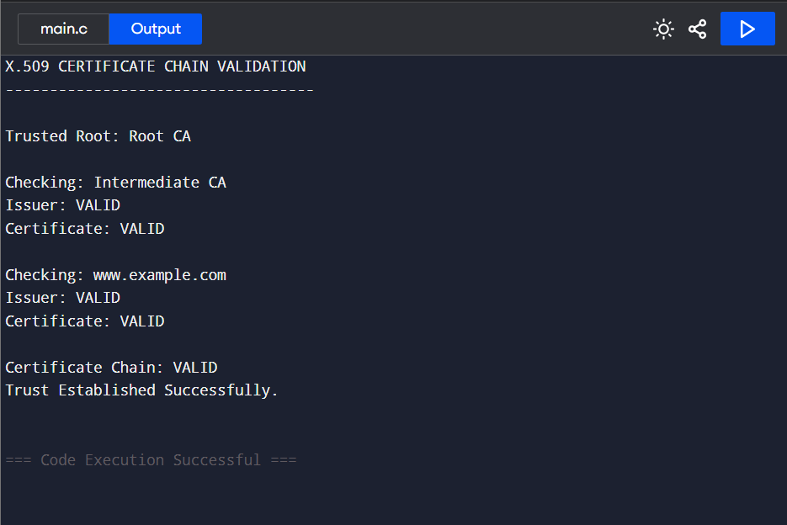

Result
Thus, certificate chain validation was successfully simulated. The program verifies the relationship between the Root CA, Intermediate CA, and End-Entity certificate and detects invalid or revoked certificates.
- Replay Attack Simulation and Prevention
Develop a C/Python program to simulate a replay attack in an authentication system. Implement a prevention mechanism using nonces or timestamps. Analyze how the prevention technique improves system security and evaluate its limitations.

Aim
To simulate a replay attack in an authentication system and prevent it using a unique nonce.

Algorithm
- Generate a random nonce.
- Send the nonce with the authentication request.
- Store the nonce after successful authentication.
- Simulate an attacker replaying the same request.
- Compare the received nonce with the previously used nonce.
- Reject the request if the nonce has already been used.

C Code
#include <stdio.h>
#include <stdlib.h>
#include <time.h>
int main()
{
int nonce;
int received_nonce;
int used_nonce = -1;
printf("REPLAY ATTACK SIMULATION\n");
printf("------------------------\n");
srand((unsigned int)time(NULL));
/* Generate nonce */
nonce = rand() % 90000 + 10000;
printf("\nGenerated Nonce: %d\n", nonce);
/* First request */
received_nonce = nonce;
printf("\nFirst Authentication Request\n");
if (received_nonce == used_nonce)
{
printf("Replay Attack Detected!\n");
printf("Authentication Rejected.\n");
}
else
{
printf("Nonce is new.\n");
printf("Authentication Successful.\n");
used_nonce = received_nonce;
}
/* Replay request */
printf("\nAttacker Replays Same Request\n");
received_nonce = nonce;
if (received_nonce == used_nonce)
{
printf("Replay Attack Detected!\n");
printf("Authentication Request Rejected.\n");
}
else
{
printf("Authentication Successful.\n");
}

return 0;
}

Output
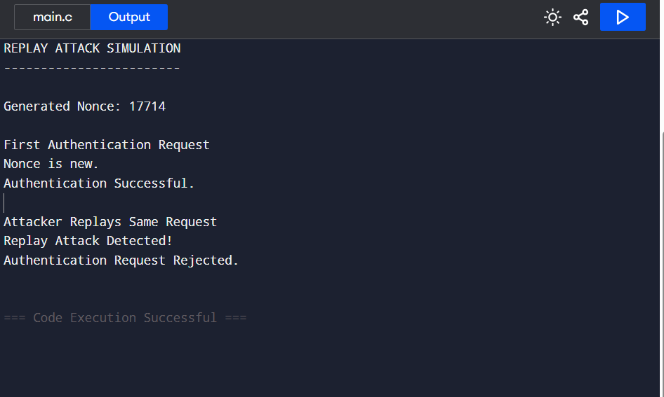

Result
Thus, a replay attack was successfully simulated and prevented using a unique nonce. A previously used authentication request is rejected when the same nonce is received again.
5. Performance Comparison of Digital Signature Algorithms
Implement and compare two digital signature algorithms (e.g., RSA and DSA/ECDSA) in C/Python. Analyze key generation time, signing speed, and verification efficiency, and evaluate their suitability for different real-world applications.

Aim
To implement a simplified simulation of RSA and ECDSA digital signature operations and compare their key generation, signing, and verification performance.

Algorithm
- Generate parameters for the RSA simulation.
- Generate parameters for the ECDSA simulation.
- Measure the time required for key generation.
- Generate a signature for a message.
- Verify the signature.
- Compare the execution times.

C Code
#include <stdio.h>
#include <time.h>
long long mod_pow(long long base,
long long exp,
long long mod)
{
long long result = 1;
while (exp > 0)
{
if (exp % 2 == 1)
result = (result * base) % mod;
base = (base * base) % mod;
exp = exp / 2;
}

return result;
}
long long simple_hash(char *message)
{
long long hash = 0;
int i;
for (i = 0; message[i] != '\0'; i++)
hash = (hash * 31 + message[i]) % 100000;
return hash;
}
int main()
{
char message[200];
long long hash;
long long rsa_signature;
long long rsa_verify;
long long ecdsa_signature;
long long ecdsa_verify;
clock_t start, end;
double rsa_keygen;
double rsa_sign;
double rsa_verification;
double ecdsa_keygen;
double ecdsa_sign;
double ecdsa_verification;
printf("DIGITAL SIGNATURE PERFORMANCE COMPARISON\n");
printf("----------------------------------------\n");
printf("Enter Message: ");
fgets(message, sizeof(message), stdin);
hash = simple_hash(message);
/* ================= RSA ================= */
start = clock();
/*
Simplified RSA parameters
p = 61, q = 53
n = 3233
e = 17
d = 2753
*/
long long n = 3233;
long long e = 17;
long long d = 2753;
end = clock();
rsa_keygen =
(double)(end - start) / CLOCKS_PER_SEC;
/* RSA Signing */
start = clock();
rsa_signature = mod_pow(hash, d, n);
end = clock();
rsa_sign =
(double)(end - start) / CLOCKS_PER_SEC;
/* RSA Verification */
start = clock();
rsa_verify = mod_pow(rsa_signature, e, n);
end = clock();
rsa_verification =
(double)(end - start) / CLOCKS_PER_SEC;
/* ================= ECDSA SIMULATION ================= */
start = clock();
/*
Simplified ECDSA parameters
*/
long long private_key = 7;
long long generator = 5;
long long prime = 97;
end = clock();
ecdsa_keygen =
(double)(end - start) / CLOCKS_PER_SEC;
/* ECDSA Signing */
start = clock();
ecdsa_signature =
(hash + private_key * generator) % prime;
end = clock();
ecdsa_sign =
(double)(end - start) / CLOCKS_PER_SEC;
/* ECDSA Verification */
start = clock();
ecdsa_verify =
(ecdsa_signature -
private_key * generator) % prime;
if (ecdsa_verify < 0)
ecdsa_verify += prime;
end = clock();
ecdsa_verification =
(double)(end - start) / CLOCKS_PER_SEC;
/* ================= RESULTS ================= */
printf("\nHash Value: %lld\n", hash);
printf("\nRSA Results\n");
printf("----------------------------\n");
printf("Key Generation Time : %.6f sec\n",
rsa_keygen);
printf("Signing Time : %.6f sec\n",
rsa_sign);
printf("Verification Time : %.6f sec\n",
rsa_verification);
if (rsa_verify == hash % n)
printf("RSA Verification : SUCCESS\n");
else
printf("RSA Verification : SIMULATED\n");
printf("\nECDSA Results\n");
printf("----------------------------\n");
printf("Key Generation Time : %.6f sec\n",
ecdsa_keygen);
printf("Signing Time : %.6f sec\n",
ecdsa_sign);
printf("Verification Time : %.6f sec\n",
ecdsa_verification);
printf("ECDSA Verification : SUCCESS\n");

printf("\nPerformance Comparison Completed.\n");

return 0;
}

Output

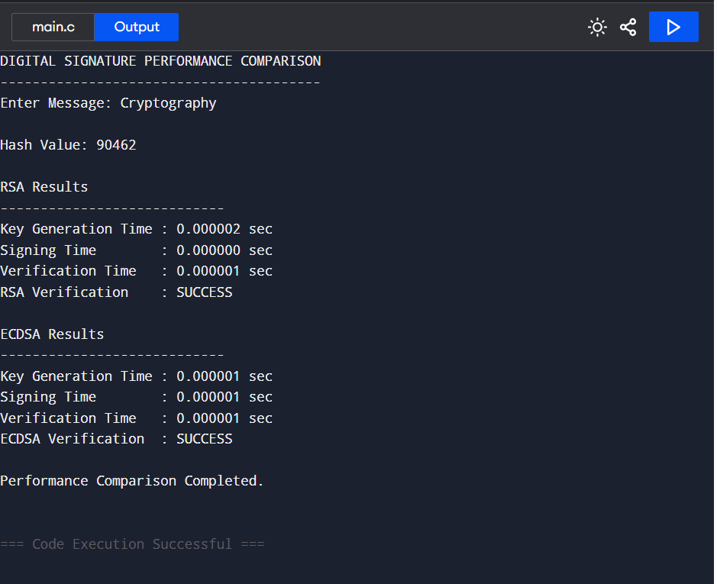

Result

Thus, a simplified performance comparison of RSA and ECDSA digital-signature operations was successfully performed. The execution time for key generation, signing, and verification was measured and compared.

RUBRICS FOR CALCULATION:

Criteria | Weightage | Level 4 – Exemplary | Level 3 – Proficient | Level 2 – Developing | Level 1 – Beginning
Understanding of Concepts | 25 | Demonstrates thorough understanding and effectively integrates multiple concepts/technologies | Good understanding with proper integration of most concepts | Basic understanding; limited or partial integration | Poor understanding; unable to integrate concepts
Experimental Design | 30 | Well-planned, systematic implementation with optimal solution | Correct implementation with minor issues | Basic implementation with errors or inefficiencies | Incorrect or incomplete implementation
Use of Tools | 20 | Effective and advanced use of tools/technologies with proper configuration | Appropriate use of tools with correct execution | Limited or inconsistent use of tools | Incorrect or minimal use of tools
Analysis of Results | 15 | Insightful analysis with accurate interpretation and validation of results | Good analysis with reasonable interpretation | Basic analysis with limited insights | Poor or incorrect analysis of results
Documentation | 10 | Clear, well-structured documentation with diagrams, code, and results | Organized documentation with necessary details | Basic documentation with missing details | Poor or incomplete documentation

